ONLINE COURIER MANAGEMENT SYSTEM
Software Requirements Specification

Version 1.0



Group Id: F230228180
Supervisor Name: Dr. Nida Anwar

Revision History
Date (dd/mm/yyyy) | Version | Description | Author
04/12/2023 | 1.0
 |  | In today’s fast-paced world, the efficient management of courier services is critical for businesses and individuals alike. The “Online Courier Management System,” developed using Java and MySQL, represents a comprehensive solution to address the challenges and demands of the logistics industry. This project offers a wide range of features designed to streamline the entire courier process, benefiting users, administrators, and staff members. | bc220401818  Irba Rizwan

Table of Contents

- Scope (of the project)
- Functional Requirements Non Functional requirements
- Use Case Diagram
- Usage Scenarios
- Adopted Methodology
- Work Plan (Use MS Project to create Schedule/Work Plan)

SRS Document

Scope of Project:

In today’s fast-paced world, the efficient management of courier services is critical for businesses and individuals alike. The “Online Courier Management System,” developed using Java and MySQL, represents a comprehensive solution to address the challenges and demands of the logistics industry. This project offers a wide range of features designed to streamline the entire courier process, benefiting users, administrators, and staff members.
The “Online Courier Management System” empowers administrators with tools for dynamic cost management. Admins can update costs based on market conditions and business requirements, ensuring competitive pricing that aligns with industry standards. Additionally, admins have access to comprehensive courier tracking capabilities, allowing them to monitor parcels, delivery timelines, and overall performance, thereby ensuring efficient and accountable operations.
In conclusion, this project represents a significant advancement in the courier management industry. Its user-friendly interface, real-time tracking capabilities, streamlined staff management, and dynamic cost control make it a valuable asset for businesses and individuals alike. By providing complete details tracking for both administrators and users, this system promotes transparency, accountability, and overall customer satisfaction, ultimately redefining the courier management landscape.
Existing system
- The existing system of courier management, prior to the implementation of the “Online Courier Management System,” operated with several core functionalities that served as the foundation for managing courier services. This traditional approach relied on manual processes and lacked the automation and efficiency features that modern technology provides.
- In the existing system, the process of booking courier services was predominantly carried out through physical channels, such as in-person visits to courier offices or phone calls. This manual booking process often required customers to provide sender and recipient details, parcel specifications, and delivery preferences in person or over the phone. This method, while functional, was time-consuming and less convenient compared to online booking systems.
- Receipt management in the existing system involved the generation of paper receipts for each courier transaction. Customers received physical copies of these receipts as proof of their bookings. These paper-based receipts, although widely accepted, were susceptible to loss or damage, which could lead to disputes or complications.
Proposed system
The proposed Online Courier Management System represents a significant advancement in the management of courier services, leveraging technology to overcome the limitations of the existing system. The proposed system is a Java and MySQL-based project that revolutionizes the courier management industry by providing a comprehensive and user-friendly platform for both users and administrators. This project encompasses a wide array of features, including User courier booking, User receipt management, User Courier tracking, New Staff registration, New Staff approval by admin, Admin cost management, Admin courier tracking, Staff Pickup assignment based on location, Staff Delivery assignment based on location, and extensive data tracking for both admin and users.
The proposed system transforms the courier management process into a digital platform, eliminating the need for physical paperwork and in-person interactions. Customers and staff can access the system online, streamlining operations and improving accessibility. The system prioritizes user convenience by offering a user-friendly interface for booking courier services. Customers can easily input sender and recipient details, parcel specifications, and delivery preferences, simplifying the booking process.
Receipts in the proposed system are generated digitally, offering customers secure and easily retrievable proof of their transactions. This eliminates the risks associated with physical receipts, such as loss or damage. Real-time tracking is a cornerstone of the proposed system. Customers can track the status and location of their parcels online, providing them with up-to-the-minute information about their deliveries.
Staff registration and approval processes are automated in the proposed system, reducing administrative overhead and expediting staff onboarding. The system ensures that only approved personnel gain access. The system provides administrators with tools for dynamic cost management. Pricing models can be adjusted in real-time, allowing the courier company to remain competitive and adapt to market fluctuations.

Functional and non Functional Requirements:

FUNCTIONAL REQUIRMENTS: -
- The admin must submit their system credentials to access the admin side after logging in.
- After logging in, the admin is redirected to the default dashboard which displays a summary of the system data.
- The admin can now submit information for new branches through the New Branch Page of the courier company.
- The Branches page displays and manages all courier company locations.
- The system admin can create new users for specific branches.
- The Branch Staff List Page displays and manages all system users across branches.
- The New Parcel Page is where system users can submit information about parcels, including
- details of the sender, destination, date, time, amount, recipient and all.
- The Parcel List Page is where parcels are listed and managed. It is the page where you can view and organize all your parcels in one place.
- The Parcel List Page is the page where the parcels are displayed and managed. It provides a list of all the parcels and allows users to perform various actions on them such as adding, editing, or deleting parcels.
- The Track Parcel Page displays the current location of the client's packages.
- The Report Page displays a printable list of courier transactions with clients.
NON-FUNCTIONAL REQUIREMENTS
Usability:
Usability of the software can be easy so that the user can use it easily without any difficulty
Maintainability:
Software should be built up in such a way that classification of errors and maintains of application becomes easy
Operating System:
Software should be able to run on all type of operating systems like Windows XP, Window 7 and others.
Some of the others are:
Accessibility
Security
Actors:
The system consists of two main modules as follows:
Admin
Sender
Tools: PHP, MySQL, VsCode, Google Chrome , Notepad++ etc.
Application Type: Web based Application
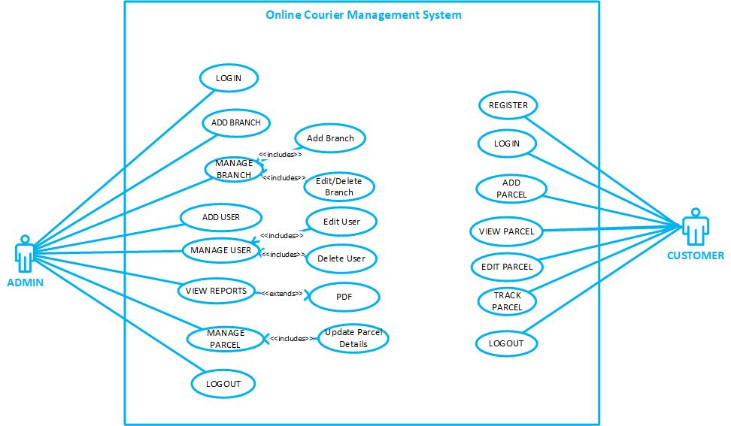
Use Case Diagram(s):

USAGE SCENARIOS:
REGISTER:

Use Case id | 1
Use Case title | REGISTER
Description | All customers who wants to use this system to send parcel or courier must have to register themselves on this website.
Pre-condition | Application interface must be available.
Action | - Open application interface of create account  - Fill the form of registration  - Click on “Register” button to get registered
Post Conditions | Customer successfully created in database.
Alternative Path: | Customer may not want to register this time
Exception: | If the customer entered invalid data in the form then the exception occurs “Fill mandatory Fields”
Authority | Customer
Author | Irba Rizwan (BC220401818)

LOGIN:

Use Case id | 2
Use Case title | LOGIN
Description | All stakeholders/Actors of the website must have to login to use some key features of this website.
Pre-condition | Actors must be registered with our website , Application interface must be available
Action | - Open application interface of login  - Enter user name and password  - Click on “Login” button
Post Conditions | Actors successfully login and able to further work
Alternative Path: | Actors may not want to login this time
Exception: | If the user entered invalid data in the form then the exception occurs “Invalid user name and password”
Authority | Customer, Admin
Author | Irba Rizwan (BC220401818)

ADD BRANCH:

Use Case id | 3
Use Case title | ADD BRANCH
Description | This use case allows admin of the system to maintain to add different branches of courier services in different cities
Pre-condition | Admin user of the system must be registered with our website and logged in.
Action | - Login as Admin  - Fill add branch form  - Click on “Add New Branch” button
Post Conditions | Branch successfully added in database and available to customers
Alternative Path: | -
Exception: | If the user entered invalid data in the form then the exception occurs “Please enter correct and valid data”
Authority | Admin
Author | Irba Rizwan (BC220401818)

ADD USER:

Use Case id | 4
Use Case title | ADD USER
Description | This use case allows admin of the system to add users which is later on be able to use this software.
Pre-condition | Admin user of the system must be registered with our website and logged in.
Action | - Login as Admin  - Fill add user form  - Click on “Add User” button
Post Conditions | Users successfully added and available on our website.
Alternative Path: | -
Exception: | If the user entered invalid data in the form then the exception occurs “Please enter correct and valid data”
Authority | Admin
Author | Irba Rizwan (BC220401818)

MANAGE USERS:

Use Case id | 5
Use Case title | MANAGE USERS
Description | This usecase allows admin user of the system to manage all Users registered on our website any time
Pre-condition | Application interface must be available. And system must be logged in as Admin
Action | - Open application interface of create account  - View manage_user.php page  - Select Particular user to manage  - Perform your desired actions(edit/delete)
Post Conditions | Updated information added in database.
Alternative Path: | Admin may not want to manage user this time
Exception: | If the user entered invalid data in the form then the exception occurs “Fill mandatory Fields”
Authority | Admin
Author | Irba Rizwan (BC220401818)

MANAGE BRANCHES:

Use Case id | 5
Use Case title | MANAGE BRANCHES
Description | This usecase allows admin user of the system to manage all branches available on our website any time
Pre-condition | Application interface must be available. And system must be logged in as Admin
Action | - Open application interface of create account  - View manage_branches.php page  - Select Particular branch to manage  - Perform your desired actions(edit/delete)
Post Conditions | Updated information of branch is added in database.
Alternative Path: | Admin may not want to manage branch this time
Exception: | If the user entered invalid data in the form then the exception occurs “Fill mandatory Fields”
Authority | Admin
Author | Irba Rizwan (BC220401818)

VIEW REPORTS:

Use Case id | 7
Use Case title | GENERATE REPORTS
Description | This use case is about generating/viewing different reports of our system
Pre-condition | Application interface must be available. And system must be logged in as Admin
Action | - Open application interface of create account  - Click on “View Reports” button  - Select Your desired report i.e monthly daily etc
Post Conditions | Reports generated successfully.
Alternative Path: | -
Exception: | If user is not admin this will not work
Authority | Admin
Author | Irba Rizwan (BC220401818)

MANAGE PARCEL:

Use Case id | 8
Use Case title | MANAGE PARCEL
Description | This usecase allows admin user of the system to manage all parcels and update status of parcels added by Customer.
Pre-condition | Application interface must be available. And system must be logged in as Admin
Action | - Open application interface of create account  - View manage_parcels.php page  - Select Particular Parcel to manage  - Perform your desired actions(Add status of the parcel)
Post Conditions | Status of parcel is Upated and added in database.
Alternative Path: | Admin may not want to manage parcel this time
Exception: | If invalid data entered in the form then the exception occurs “Fill mandatory Fields”
Authority | Admin
Author | Irba Rizwan (BC220401818)

ADD PARCEL:

Use Case id | 9
Use Case title | ADD PARCEL
Description | This use case is about adding parcel.
Pre-condition | Application interface must be available. And system must be logged in as Customer
Action | - Open application interface and open add parcel interface  - Add details of parcel i.e sender name , receiver name, parcel details, parcel weight in a web form  - Click on Add parcel
Post Conditions | Parcel submitted and available for customer to view status
Alternative Path: | -
Exception: | If invalid data entered in the form then the exception occurs “Fill mandatory Fields”
Authority | Customer
Author | Irba Rizwan (BC220401818)

VIEW PARCEL:

Use Case id | 10
Use Case title | VIEW PARCEL
Description | This use case allows customers to view the parcel which he has sent by using this system
Pre-condition | Application interface must be available
Action | - Open application interface select the view parcel tab.  - Details of all parcel are visible to customers
Post Conditions | Details of all parcel sent / received to be make visible to customers
Alternative Path: | Customer may not want to view parcel this time
Exception: | If customer is not logged in this use case does not work
Authority | Customer
Author | Irba Rizwan (BC220401818)

TRACK PARCEL:

Use Case id | 10
Use Case title | TRACK PARCEL
Description | This use case allows customers to view the status of the parcel which he has sent by using this system
Pre-condition | Application interface must be available
Action | - Open application interface select the view parcel tab.  - Select your desired parcel  - Current status of the parcel is visible to customer
Post Conditions | Status of all parcel sent / received to be make visible to customers
Alternative Path: | -
Exception: | If customer is not logged in this use case does not work
Authority | Customer
Author | Irba Rizwan (BC220401818)

LOGOUT

Use Case id | 12
Use Case title | LOGOUT
Description | This use case allows all the actors of the system to logout from website.
Pre-condition | The application interface must be available and any of the actor must be Logged in.
Action | - Open application interface.  - Click on Logout Button.
Post Conditions | Session is destroyed and actor will be logout from system.
Alternative Path: | Force close website.
Exception: | If session is empty than this feature is not available.
Authority | Admin,Customers
Author | Irba Rizwan (BC220401818)

Adopted Methodology
Development of any software product or application choice of right model is very important. The selection of model has very high impact on the testing that is carried out. It will define that what, where and when of our planned testing, influence regression testing and which test techniques to use. The development models are the various processes or methodologies that are being selected for the development of the project depending on the project aims and goals. There are many development life cycle models that have been developed in order to achieve different required objectives. The models specify the various stages of the process and the order in which they are carried out There are various Software development models or methodologies we discus Water Fall and Spiral Model in the following.

Waterfall Model:
The waterfall Model is a linear sequential flow. In which progress is seen as flowing steadily downwards (like a waterfall) through the phases of software implementation. This means that any phase in the development process begins only if the previous phase is complete. The waterfall approach does not define the process to go back to the previous phase to handle changes in requirement. The waterfall approach is the earliest approach that was used for software development.
Diagram
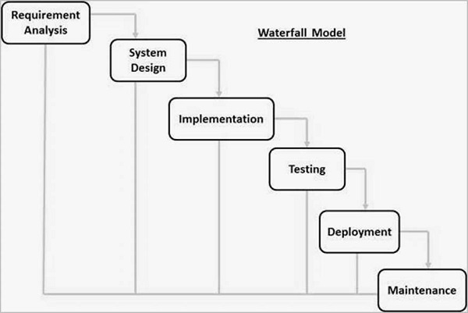
Spiral Model:
The spiral model is similar to the incremental model, with more emphasis placed on risk analysis. The spiral model has four phases: Planning, Risk Analysis, Engineering and Evaluation. A software project repeatedly passes through these phases in iterations (called Spirals in this model). The baseline spiral, starting in the planning phase, requirements are gathered and risk is assessed. Each subsequent spirals builds on the baseline spiral.
Planning Phase:
Requirements are gathered during the planning phase.
Risk Analysis:
A prototype is produced at the end of the risk analysis phase. If any risk is found during the risk analysis, then alternate solutions are suggested and implemented.
Engineering Phase:
In this phase software is developed, along with testing at the end of the phase. In this phase the development and testing is done.
Evaluation phase:
This phase allows the customer to evaluate the output of the project to date before the project continues to the next spiral.
Diagram of Spiral model:
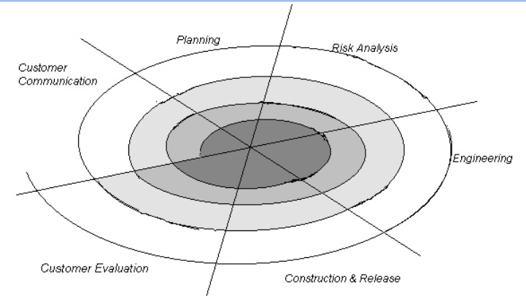
VU Process Model:
The methodology chosen for this project is VU Process Model. The vu process model, offers numerous advantages for software developers and because of its beneficial flow I use this methodology. This model is a combination of Waterfall and Coiled/Spiral Model. This is a hybrid approach of system development, which maximizes the quality of system and minimizes the disadvantages and risks.
VU process model has four phases; each phase is tested on its completion. It
conserves resources and is superlative for sustaining less skilled plan teams and project managers whose composition fluctuates. The errors are removed due to iteration to previous or next phases. The orderly sequence of development steps and strict controls for ensuring the adequacy of documentation and design reviews helps ensure the quality, reliability, and maintainability of the developed software. The progress of system development is measurable.VU Process model depicts the linear nature of waterfall and iterative risk analysis of spiral. We analyze each phase activity with the end product. VU Process model will help us in identification of risk at the time as it omits. So resolution of that risk will be much easy at that point, while if it is detected at later stage then the resolution will become much more painful and costly (time& budget). Also documentation makes the maintenance of product after its delivery easy. So by combining the spiral & waterfall we get the benefits of waterfall and risk sensitivity of the spiral.
REASONS FOR CHOOSING THE METHODOLOGY
- The Waterfall Model is a documentation-driven model. It therefore generates complete and comprehensive documentation and hence makes the maintenance task much easier. Documentation helps to keep track to risk.

- It suggests a systematic, sequential approach to software development that begins at the system level and progresses through the analysis, design, coding, testing, and maintenance.
Vu Process Model Diagram;
Analyzing & Gathering requirement

Planning Phase

Analysis & Design Phase

Development Phase

Operation & Maintenance
Analysis and Design Phase
Development Phase
Operation & Maintenance

Work Plan (Use MS Project to create Schedule/Work Plan)

SRS AND DESIGN DOCUMENT
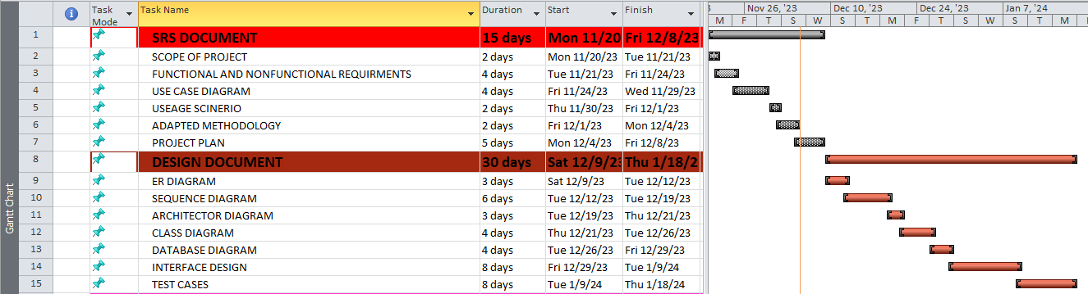

TESTPHASE AND FINAL DELIVERABLES

